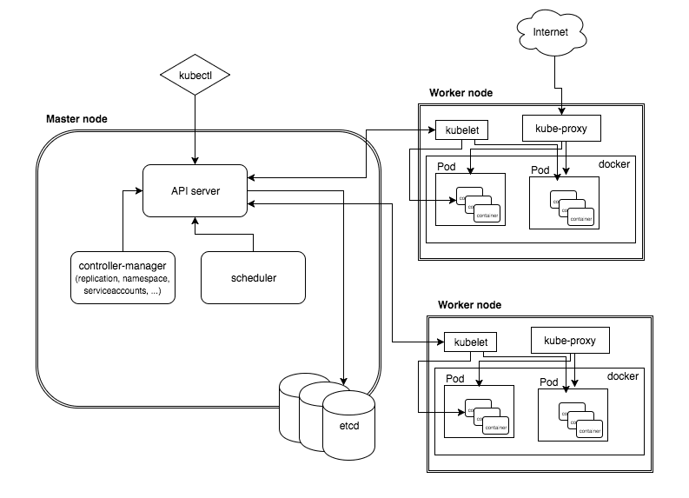

######### Kubernetes-Cluster-Master-and-Node on Centos - 8 ########

###### Describe Kubernetes Cluster Master and Worker Node,

First off all we create a Three Virtual Machine One for Master Node and two [2] Worker Node.######

**\*\*\*\*My Site\*\*\*\***

**Master ip** = 192.168.2.121

**Master Hostname** = k8master.pc

and

**Worker Node01 ip** = 192.168.2.122

**Worker Node02 ip** = 192.168.2.123

**Worker Node01 Hostname** = k8snode01.pc

**Worker Node02 Hostname** = k8snode02.pc

###### **Step [1] First Off your swap mamery** ######

$ vi /etc/fstab

### disable swap Copy and paste the line if already swap memory inclue your machine you Just Change comment [#] ###

#/dev/mapper/cl-swap swap swap defaults 0 0

$ swapoff -a

**Check It's Disable or not**

$ free -m

**Step [2] Stop firewalld & disable firewalld service**

$ systemctl stop firewalld && systemctl disable firewalld

**Check Status**

$ systemctl status firewalld

**Step [3] Disable selinux service**

$ vi /etc/selinux/config

**Line Number 7 Change the comment [disabled]**

SELINUX=disabled

**This module is required to enable transparent masquerading and to facilitate

Virtual Extensible LAN (VxLAN) traffic for communication between Kubernetes pods across the cluster**

$ modprobe br_netfilter

**Step [4] Change your Hostname**

$ hostname

$ hostnamectl set-hostname k8master.pc

**Config your Hostname [192.168.2.212 k8master.pc]**

$ vi /etc/hosts

**# Now reboot your Host PC**

# Step [5] Install Docker Engine on Your Host Machine

**Step1: IF install old Docker engine first Uninstall old versions**

$ sudo yum remove docker \

docker-client \

docker-client-latest \

docker-common \

docker-latest \

docker-latest-logrotate \

docker-logrotate \

docker-engine

**\*\*Step2: Installation methods\*\***

**\*\*1. Install using the repository\*\***

$ sudo yum install -y yum-utils

$ sudo yum-config-manager \

--add-repo \

https://download.docker.com/linux/centos/docker-ce.repo

**\*\*Install Docker Engine\*\***

**\*\*Install the latest version of Docker Engine and Container\*\***

$ sudo yum install -y docker-ce docker-ce-cli containerd.io

**\*\*Start Docker Service\*\***

$ systemctl enable docker && systemctl start docker

**\*\*Check Docker Service\*\***

$ service docker status

**\*\*Check Docker Version\*\***

$ docker version

**\*\*Check Docker Container running\*\***

$ docker ps

**\*\*Check Docker Container all\*\***

$ docker ps -a

**\*\*Create a Directory\*\***

$ mkdir /etc/docker

**Copy and Paste the Commande / file**

$ cat > /etc/docker/daemon.json <<EOF

{

"exec-opts": ["native.cgroupdriver=systemd"],

"log-driver": "json-file",

"log-opts": {

"max-size": "100m"

},

"storage-driver": "overlay2",

"storage-opts": [

"overlay2.override_kernel_check=true"

]

}

EOF

**\*\*Now Again create a Directory\*\***

$ mkdir -p /etc/systemd/system/docker.service.d

**\*\*Reload daemon\*\***

$ systemctl daemon-reload

**#### Step [6] Install kubernetes on linux machine ####**

**\*\*Copy and Paste the Command / file\*\***

$ cat <<EOF > /etc/yum.repos.d/kubernetes.repo

[kubernetes]

name=Kubernetes

baseurl=https://packages.cloud.google.com/yum/repos/kubernetes-el7-x86_64

enabled=1

gpgcheck=1

repo_gpgcheck=1

gpgkey=https://packages.cloud.google.com/yum/doc/yum-key.gpg https://packages.cloud.google.com/yum/doc/rpm-package-key.gpg

EOF

$ sed -i 's/^SELINUX=enforcing$/SELINUX=permissive/' /etc/selinux/config

**\*\*Install Command on Kubernetes\*\***

$ yum install -y kubelet kubeadm kubectl --disableexcludes=kubernetes

cat <<EOF > /etc/sysctl.d/k8s.conf

net.bridge.bridge-nf-call-ip6tables = 1

net.bridge.bridge-nf-call-iptables = 1

EOF

**\*\*Chweck sysctl System\*\***

$ sysctl --system

**\*\*Enable Kubelet\*\***

$ systemctl enable kubelet

**\*\*\* Note: This Step Follow All Three Machine, Master and Worker Node \*\*\***

**########## Task to do in only Master node ########## If you can choice Option anyone**

$ kubeadm init --apiserver-advertise-address=192.168.2.121 --pod-network-cidr=10.244.0.0/16

or

$ kubeadm init --control-plane-endpoint "192.168.2.212:6443" --pod-network-cidr=10.244.0.0/16

or

$ kubeadm init --apiserver-advertise-address=192.168.2.212 --pod-network-cidr=192.168.0.0/16 --service-cidr=192.168.1.0/24

***Note: Take a few minute

**### Copy All file Your Txt file (Example below) ###**

To start using your cluster, you need to run the following as a regular user:

mkdir -p $HOME/.kube

sudo cp -i /etc/kubernetes/admin.conf $HOME/.kube/config

sudo chown $(id -u):$(id -g) $HOME/.kube/config

Alternatively, if you are the root user, you can run:

export KUBECONFIG=/etc/kubernetes/admin.conf

You should now deploy a pod network to the cluster.

Run "kubectl apply -f [podnetwork].yaml" with one of the options listed at:

https://kubernetes.io/docs/concepts/cluster-administration/addons/

Then you can join any number of worker nodes by running the following on each as root:

kubeadm join 192.168.2.121:6443 --token p8r1a2.msnjnqjh36ft443w \

--discovery-token-ca-cert-hash sha256:33e34bfcbe5d0e1a9a58757e1534eb90ef1076625e9d15c652425d921e4a8e91

**### And Copy token (Example below) For Worker Node uses ###**

kubeadm join 192.168.2.121:6443 --token p8r1a2.msnjnqjh36ft443w \

--discovery-token-ca-cert-hash sha256:33e34bfcbe5d0e1a9a58757e1534eb90ef1076625e9d15c652425d921e4a8e91

**### Now Run the Command and process ###**

$ mkdir -p $HOME/.kube

$ sudo cp -i /etc/kubernetes/admin.conf $HOME/.kube/config

$ sudo chown $(id -u):$(id -g) $HOME/.kube/config

**### Configure Pod Network with Flannel ###**

$ kubectl apply -f https://raw.githubusercontent.com/coreos/flannel/2140ac876ef134e0ed5af15c65e414cf26827915/Documentation/kube-flannel.yml

**### Untainted master ##**

$ kubectl taint nodes --all node-role.kubernetes.io/master-

**### Check Nodes are Master Machine ###**

$ kubectl get nodes -A

**### Check all pods in service ####**

$ kubectl get pods --all-namespaces -o wide

**### Check all nodes in service ####**

$ kubectl get nodes --all-namespaces -o wide

**#### pode delete command ######**

$ kubectl delete deployment <kubernetes-dashboard> --namespace=<kubernetes-dashboard>

$ kubectl delete deployment <dashboard-metrics-scraper> --namespace=<kubernetes-dashboard>

**#### Task to do in Worker Node ####**

1. worker node connect with cluster using token.( Copy and Paste)

Example: kubeadm join 192.168.2.121:6443 --token ab9lu9.l9pmvfid0lbx0ska \

--discovery-token-ca-cert-hash sha256:1f91ec32fcb126f55c3b9a7c613fbd8570e08bd4c14e0a14d3043a6c6a15963e

###For worker node when problem####

swapoff -a

kubeadm reset --force

reboot

swapoff -a

**### kubeadm reset Command ###**

$ kubeadm reset

**#### Install Kubernetes Dash-Board ######**

$ kubectl apply -f https://raw.githubusercontent.com/kubernetes/dashboard/v2.2.0/aio/deploy/recommended.yaml

**#### Create Admin User ####**

$ kubectl create serviceaccount -n kubernetes-dashboard admin-user

**### Create yml file and Define role ###**

$ vi rbac.yml

### Copy and paste the yml file ###

apiVersion: rbac.authorization.k8s.io/v1

kind: ClusterRoleBinding

metadata:

name: admin-user

roleRef:

apiGroup: rbac.authorization.k8s.io

kind: ClusterRole

name: cluster-admin

subjects:

- kind: ServiceAccount

name: admin-user

namespace: kubernetes-dashboard

**### Apply / run yml file ###**

$ kubectl apply -f rbac.yml

**### confirm security token of the account ###**

$ kubectl -n kubernetes-dashboard describe secret $(kubectl -n kubernetes-dashboard get secret | grep admin-user | awk '{print $1}')

**#### if access from other client hosts, set port-forwarding ###**

$ kubectl -n kubernetes-dashboard edit service kubernetes-dashboard

**\*\*\* Just Change [ClusterIP to NodePort]**

**### Show Services Port ###**

$ kubectl get services --all-namespaces

**## Show all namespaces service ##**

kubernetes-dashboard kubernetes-dashboard NodePort 10.103.154.32 <none> 443:30690/TCP 6m57s

### Now Hit your Web Browser ###

https://192.168.2.121:30690

Or

#### You run kube-proxy ####

$ kubectl proxy

### Now Hit your Web Browser ###

http://localhost:8001/api/v1/namespaces/kubernetes-dashboard/services/https:kubernetes-dashboard:/proxy/